CREDIT ACCOUNT APPLICATION 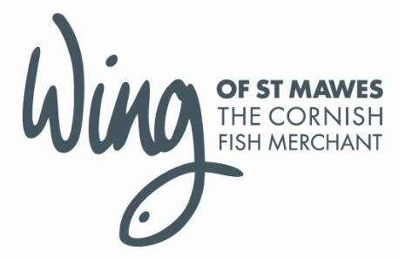
In order to open a credit account with us, please complete the details below and return either by fax to 01726 861668 or email accounts@wingofstmawes.co.uk. We will then undertake the relevant checks and will contact you with the credit terms we can offer you. Please note that this can take several days. If you wish to place an order meanwhile, please call 01726 861666 and we will be able to supply you on a ‘payment with order’ basis.

Full legal trading title:
Registered Office address:
Registered Company Number:

If applicant is not a limited company please give details of partners/proprietors:
Full name: | Full name:
Address: | Address:

Please provide contact details for ORDERS
Contact name:
Delivery address:
Telephone number:
Email address:

Please provide contact details for ACCOUNTS
Contact name:
Telephone number:
Email address:
Credit limit requested:

Please provide TRADE REFERENCES (References must be able to support the level of credit requested). To speed up the process please contact your referee and advise them that we will be contacting them.
Company name: | Company name:
Telephone: | Telephone:
Email: | Email:
Nature of business: | Nature of business:

I agree to abide by your terms & conditions. I understand and accept that failure to comply with these terms may lead to our account being place on stop and credit limits being withdrawn without prior notice.
Print name: | Signed:
Position: | Date:

To be completed by Wing of St Mawes
Account name: | Credit limit:
Notes:

